**EDUNET FOUNDATION - Class Exercise Notebook**

**Lab1 - Demonstrating the Installation of Anaconda Navigator and familiar with jupyter notebook with first program in python.**

**Exercise 1: Installation of Anaconda navigator on windows**

Anaconda is an open-source software that contains Jupyter, spyder, etc that are used for large data processing, data analytics, heavy scientific computing. Anaconda works for R and [python programming language](https://www.geeksforgeeks.org/python-language-introduction/).

**Step 1:** At first, visit the following link: [https://www.anaconda.com/download](https://www.anaconda.com/download )and the page will pop up like this, just click on Download.

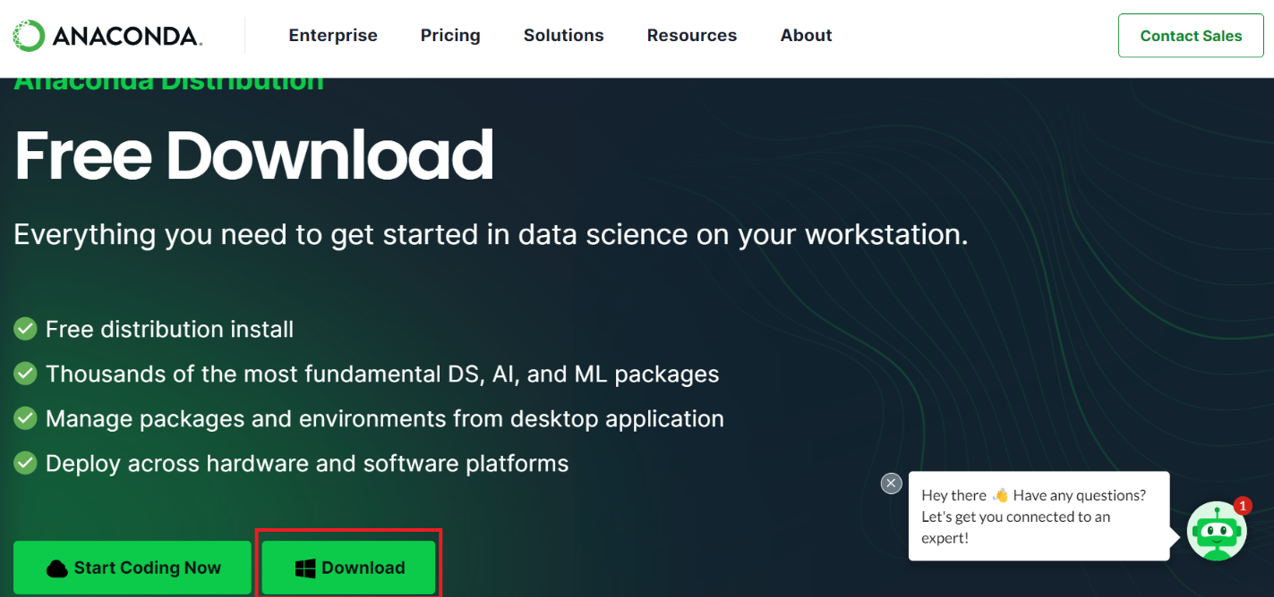

**Step 2:** After downloading the file, run the file. The file will open, Click **Next**

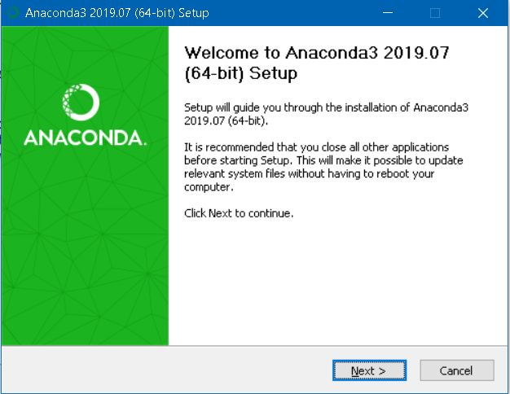

**Step 3:** And click **I Agree** to the license.

**Step 4:** Choose Just Me and click **Next.**

**Step 5:** Choose the installation location by clicking **Browse or**leave it as it is (default location) and continue to click **Next**.

**Step 6:** Here, it is highly recommended to choose the second one “**Register Anaconda as my default Python 3.7**” and click **Install.**

**Step 7:** Once the installation is done, open the **Anaconda Prompt**from Windows start menu bar.

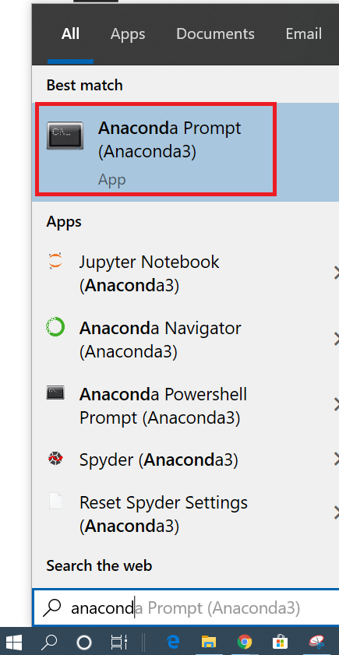

**Step 8:** Anaconda Prompt is shell similar to Windows Command Prompt (Windows Terminal) powered by Anaconda distribution. To check whether we have successfully installed Anaconda or not, type **python** command in the shell.

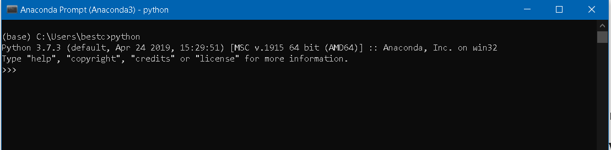

**Exercise 2: Familiar with jupyter notebook with first program in Python**

The Jupyter Notebook is an open-source web application that you can use to create and share documents that contain live code, equations, visualizations, and text. Jupyter Notebook is maintained by the people at [Project Jupyter](http://jupyter.org/).

If you already installed Anaconda in your machine, then it’s very easy to use Jupyter notebook

**Step 1:** Press window key and Just type anaconda prompt and open.

**Step 2:** Just Run command **Jupyter notebook** and hit enter

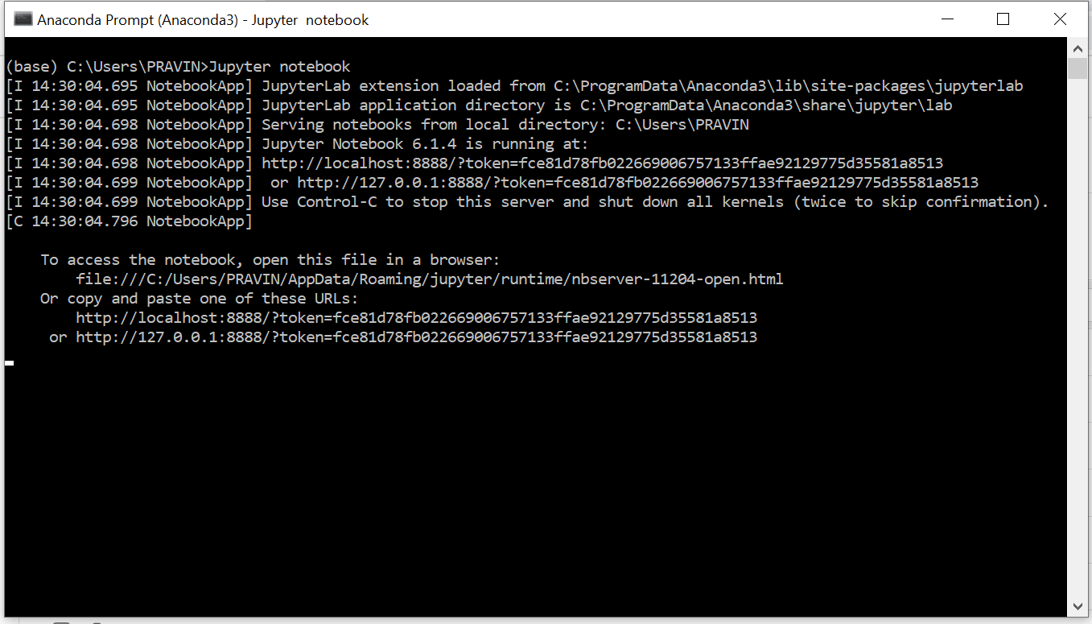

Jupyter notebook will open in your default browser, should start (or open a new tab) to the following URL: <http://localhost:8888/tree>

Your browser should now look something like this:

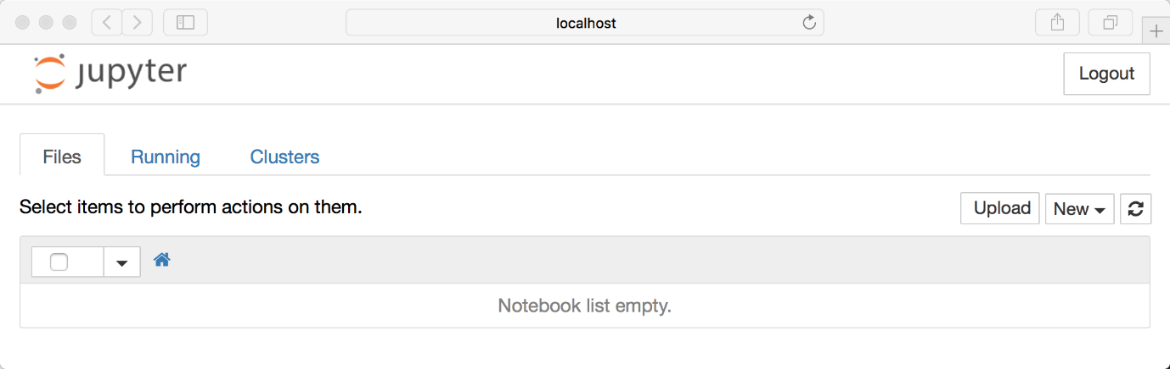

**Step 3:** To creating a notebook, Click on New and choose Python3

Now that you know how to start a Notebook server, you should probably learn how to create an actual Notebook document.

All you need to do is click on the new button (upper right), and it will open up a list of choices. Here choose python2 or Python 3, so we can create a Notebook that uses either of these. For simplicity’s sake, let’s choose Python 3.

Your web page should now look like this:

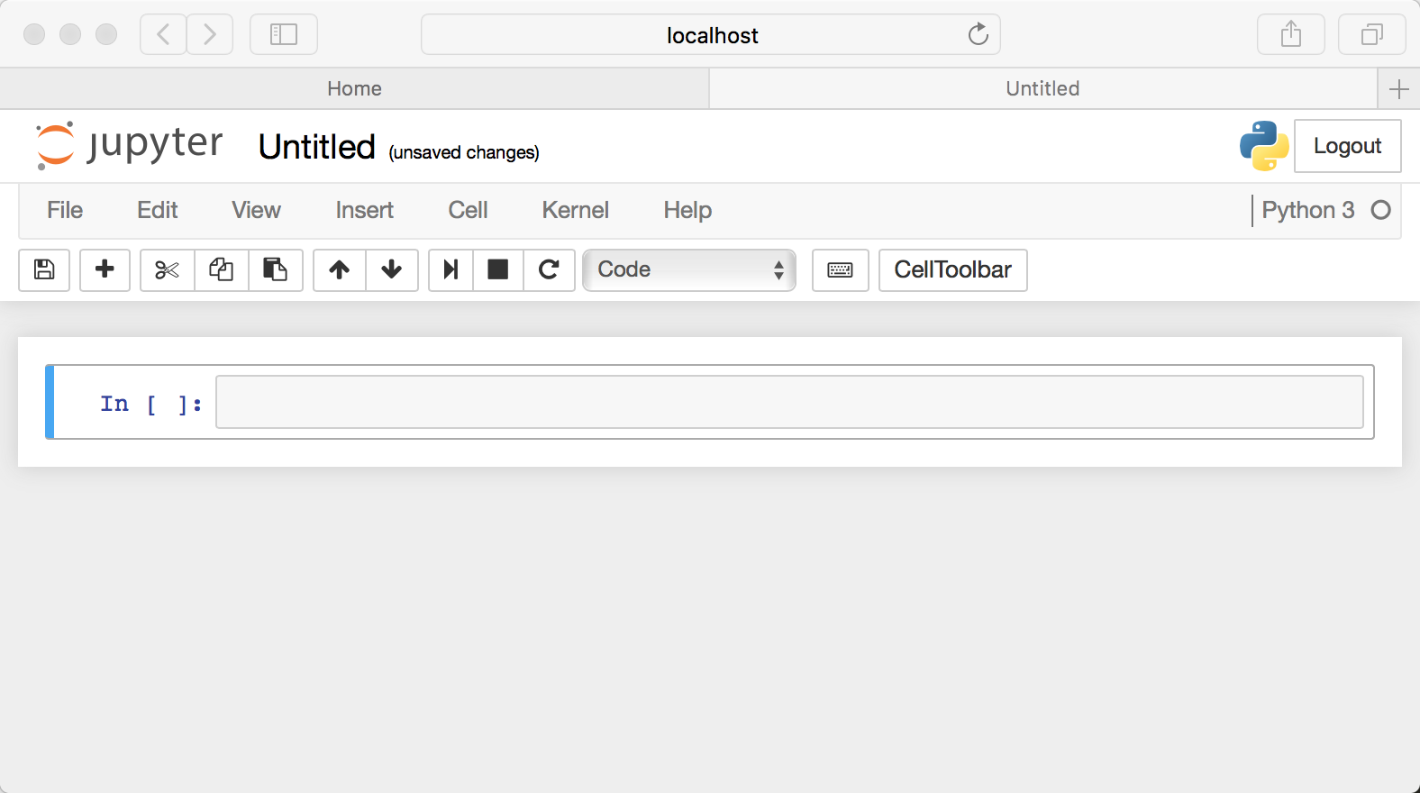

**Step 4:** Naming

You will notice that at the top of the page is the word Untitled. This is the title for the page and the name of your Notebook. Since that isn’t a very descriptive name, let’s change it!

Just move your mouse over the word Untitled and click on the text. You should now see an in-browser dialog titled Rename Notebook. Let’s rename this one to Hello Jupyter:

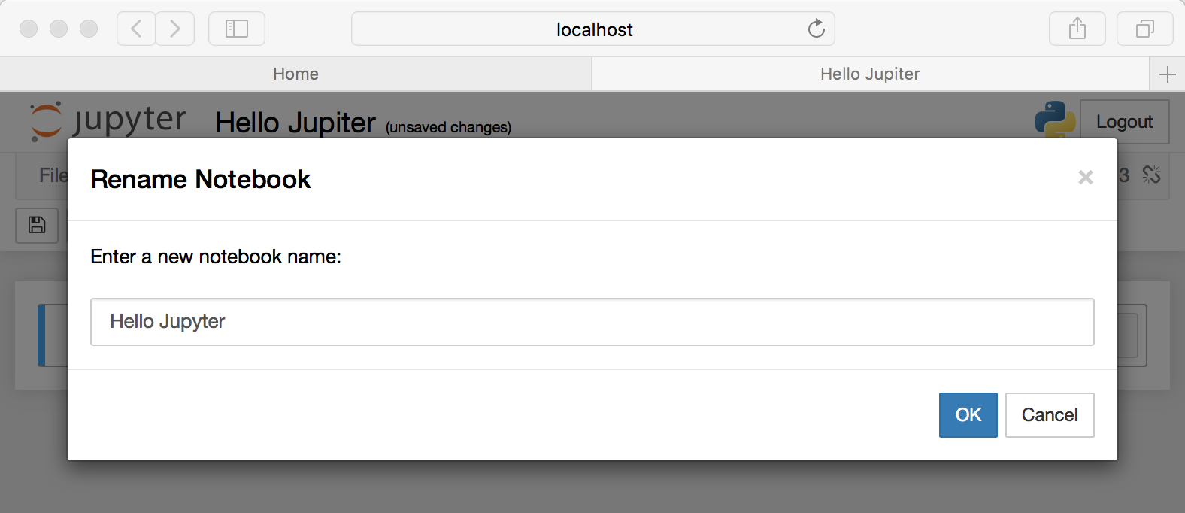

**Step 5:** Running Cells

Running a cell means that you will execute the cell’s contents. To execute a cell, you can just select the cell and click the Run button that is in the row of buttons along the top. It’s towards the middle. If you prefer using your keyboard, you can just **press Shift+Enter**.

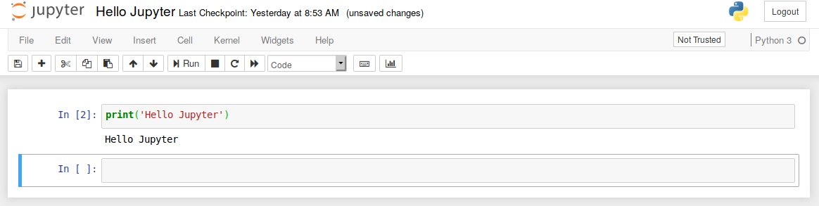

If you have multiple cells in your Notebook, and you run the cells in order, you can share your variables and imports across cells. This makes it easy to separate out your code into logical chunks without needing to reimport libraries or recreate variables or functions in every cell.

**Step 6:** In the Jupyter Notebook has several menus that you can use to interact with your Notebook. The menu runs along the top of the Notebook just like [menus](https://realpython.com/python-menus-toolbars/) do in other applications. Here is a list of the current menus:

* File
* Edit
* View
* Insert
* Cell
* Kernel
* Widgets
* Help

**Note: Explore all the Menu one by one to use of Jupyter notebook.**

**Step 7:** How to create larger or smaller headers Creating headers in Markdown is also quite simple. You just have to use the humble Hash sign. The more Hash signs you use, the smaller the header. Jupyter Notebook even kind of previews it for you:

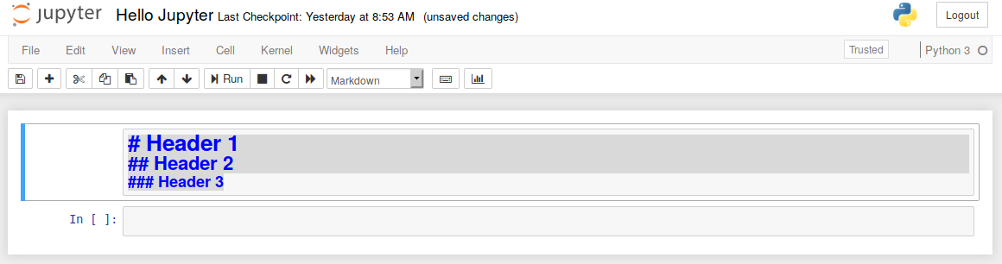

**Step 8:** Then when you run(shift+enter) the cell, you will end up with a nicely formatted header:

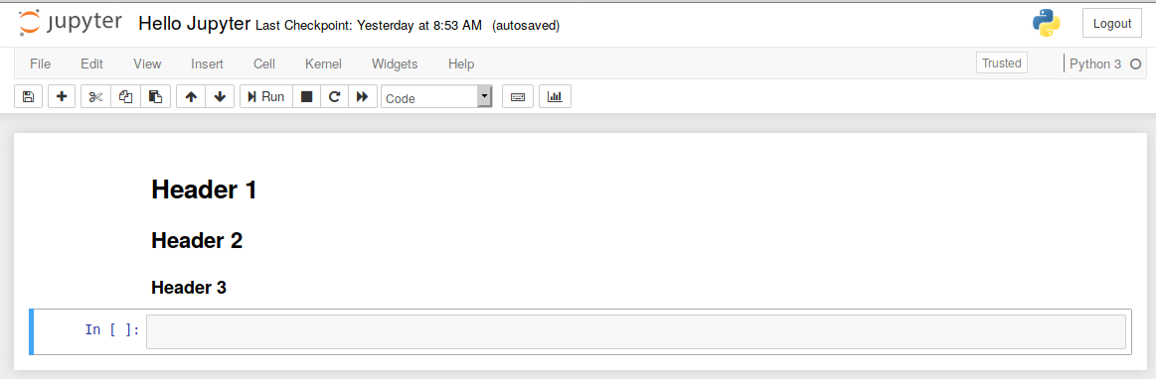

**Step 9:** Our first program in python

